3.3 Spectral Clustering
In multivariate statistics and the clustering of data, spectral clustering techniques make use of the spectrum (eigenvalues) of the similarity matrix of the data to perform dimensionality reduction before clustering in fewer dimensions. Spectral clustering techniques make use of the eigenvectors of a Laplacian matrix derived from the data to create groups of data points that are similar. In this context, the kernel function acts as a similarity measure between two data points. The Laplacian matrix is then obtained by re-scaling the kernel matrix.

We run the script sclusteringscript and obtain the following figures:
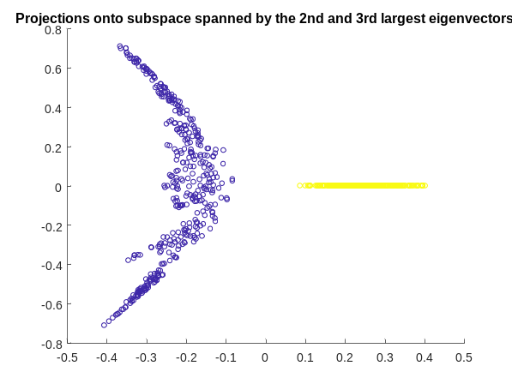
0.001
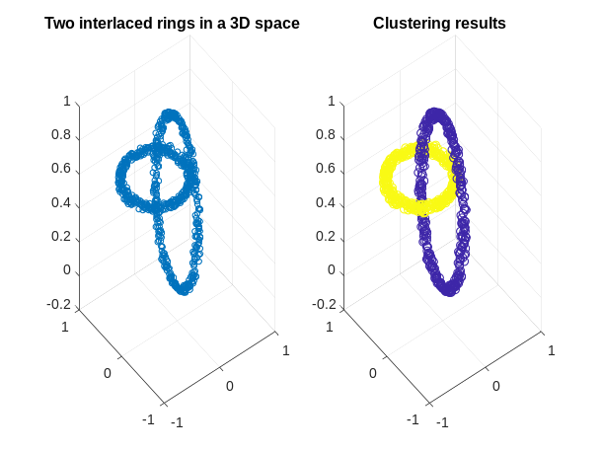

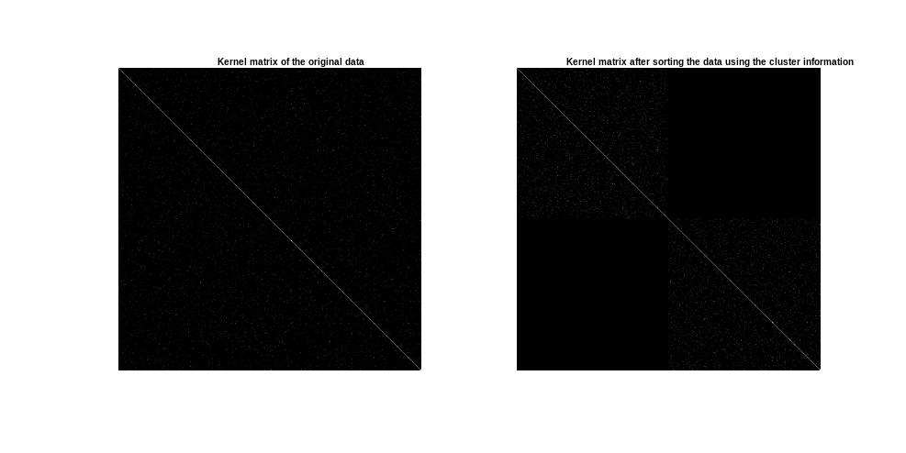

0.005
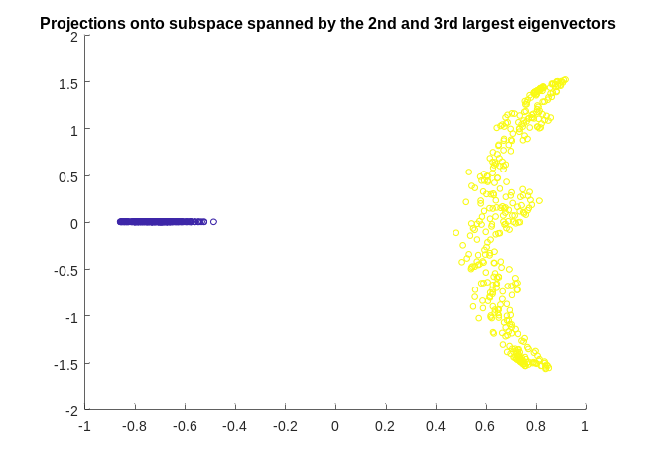
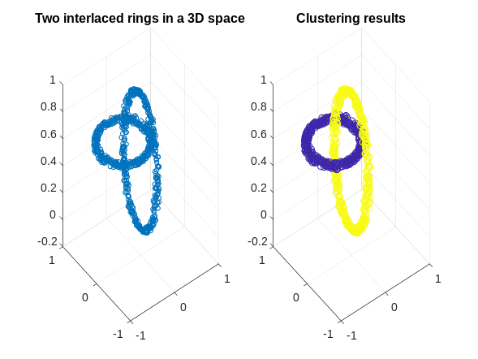
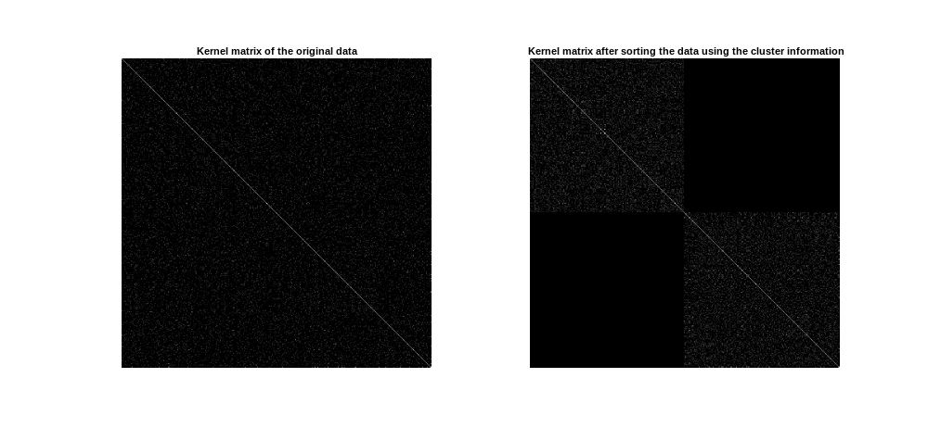

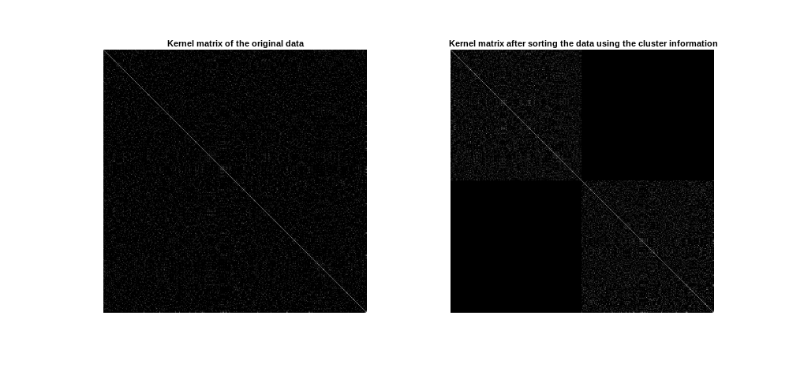
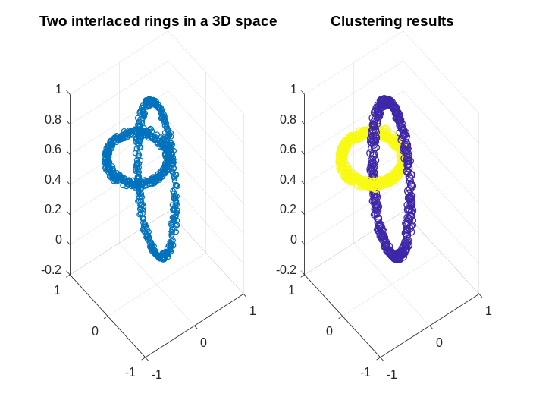
0.01
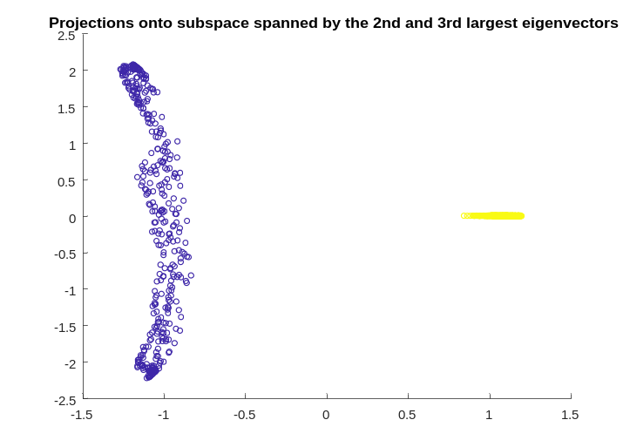

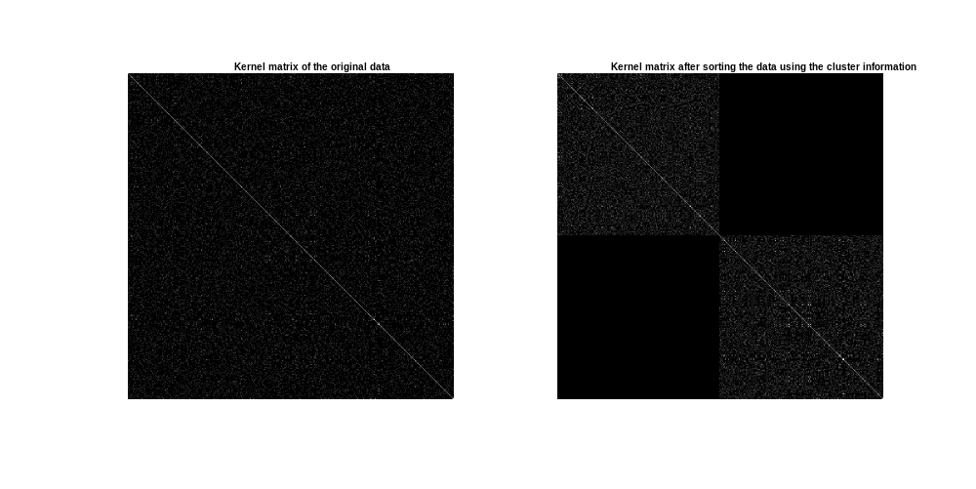

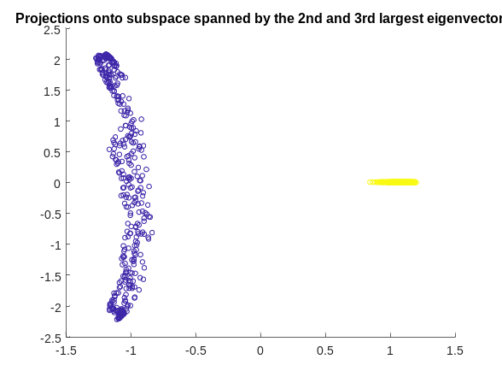
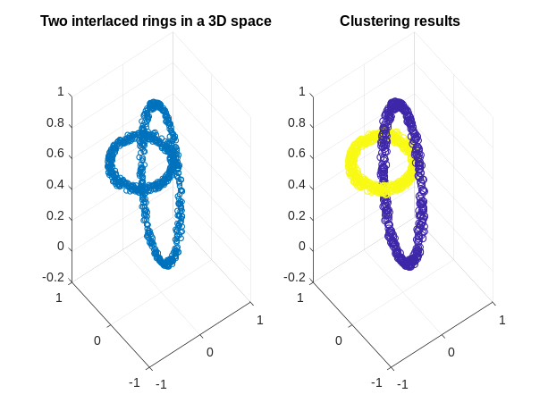
0.2

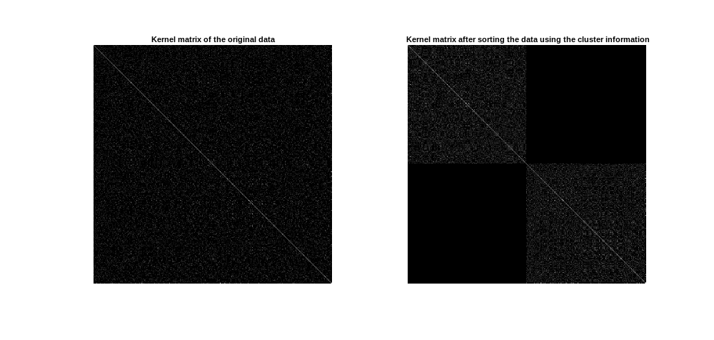

The difference with classification is that clustering is a unsupervised learning techniques (no labels available). The different with standard clustering is that, as mentioned above, spectral clustering makes use of the eigen vectors of a similarity matrix instead of the similarity matrix itself (k-means for example).
In spectral clustering with RBF kernel, _ denotes the bandwidth of the kernel. As in other kernel applications, the tuning of the parameters of the kernel is an important component to the performance of the model. A cross-validation approach can be used here.
First, a grid of possible values of the tuning parameters is constructed. Afterwards, a model is trained for each combination of parameters and a chosen criterion is evaluated on the partitioning predicted for the validation data. Finally, the parameters yielding the maximum value of the criterion are selected. In kernel, spectral clustering, a criterion based on the amount of collinearity between validation points belonging to the same cluster, in the space of the projections performs well. It reaches its maximum value 1 in case of well separated clusters.

